COVID-19
Jobsite Safety Plan

for

[insert COMPANY NAME here]

at Jobsite [insert JOBSITE LOCATION here]

GENERAL INSTRUCTIONS

- Overview
This COVID-19 Plan is an addition to our existing Accident Prevention Plan. It addresses [insert Company Name Here] and worker’s responsibilities to keep ourselves and our communities safe from this virus.

- Procedures
This document contains guidance for safety procedures to be followed and forms to be used. Supervisors are expected to integrate the procedures into the appropriate work activity and workers are expected to apply them on the job. The sample forms are to be used if they apply to the job concerned.

- Dissemination
A copy of this statement will be issued to all supervisory and management personnel. A copy of the policy statement will be posted on company safety and health bulletin boards and at the following locations:

1. (insert location here)

2. (insert location here)

- Regulations
A copy of the following documents will be maintained on each jobsite:

- Proclamation by the Governor 20-25. [See Appendix A1, 1-5, Proclamation by the Governor 20-25]

- Proclamation by the Governor 20-25.1. [See Appendix A2, 1-3 Proclamation by the Governor 20-25.1]

- Proclamation by the Governor 20-05. [See Appendix A3, 1-2 Proclamation 20-05]

- DOSH Directive 1.70. [See Appendix B 1-13 DOSH Directive, dated 12/22/20]

- Washington State Department of Health Workplace and Employer Resources and Recommendations. [See Appendix C 1-2 DOH Resources]

COMPANY POLICY LETTER

SAFETY AND HEALTH POLICY FOR [insert Company Name Here]

The purpose of this policy is to increase the already high standard of safety throughout all operations of (insert Company Name Here) by adding protections related to the COVID-19 outbreak.

This addition to our Accident Prevention Program will continue in effect throughout Phase 2/Phase 3 of the reopening, as defined by the Governor’s “Stay Home, Stay Safe” order (20-25). Phase 2/Phase 3 allows all construction, including activities for which social distancing may not be maintained and the start of new construction projects. These activities will be performed in compliance with “Phase 2 Construction Restart COVID 19 Jobsite Requirements” bulletin, posted by the Governor on May 15, 2020.

[insert Company Name Here] is committed to fulfilling the Phase 2/Phase 3 Construction Restart COVID-19 Jobsite Requirements. We are also committed to keeping ourselves and our communities healthy.

_______________________________
Signed, [insert Company President here)

RESPONSIBILITIES

- Management Officials

In this time of crisis and necessary distancing, [insert Company Name Here] encourages workers and managers to communicate without face to face contact as often as possible. To that end, all managers must have their cell phones on their person with the ringer turned on while they are at work. Managers should provide their cell phone numbers to their team members and encourage calls whenever a question arises that can be resolved over the phone.

- Supervisors

In addition to the standard safety supervision, [insert Company Name Here]] must designate a COVID-19 Supervisor who is responsible for monitoring the health of workers and enforcing this Jobsite Safety Plan.

[If your jobsite is a single-family residential site AND there are 6 or fewer people at the site at one time, your COVID-19 Supervisor does not have to be on site at all times. Otherwise, a COVID-19 Supervisor must always be at the jobsite when work is happening. The COVID-19 Supervisor may be doing normal work on the site as well.]

[insert employee name here] and [insert employee name here] are COVID-19 Supervisors for this site.

- Workers

Observe the items of responsibility established in this document as well as job safety rules which may apply to specific task assignments.

EXPOSURE CONTROL – ILLNESS AT THE WORKSITE

A. Identification of Illness

- All workers must be screened before beginning their shift by asking them if they have a fever, cough, shortness of breath, fatigue, muscle aches, or new loss of taste or smell. Any worker with a temperature of 100.4°F or higher is considered to have a fever and must be sent home.
- Workers may take their temperature at home and report the results to the employer, along with answering the screening questions, before reporting to work. If a worker does not have a thermometer at home, the employer will provide one.
- If the company takes temperatures at the worksite, they shall be ‘no touch’ or ‘no contact’ to the greatest extent possible. If a ‘no touch’ or ‘no contact’ thermometer is not available, the thermometer must be properly sanitized between each use.
- If a worker has symptoms of an acute respiratory illness, such as fever, cough, or shortness of breath, they must leave the worksite and not return until they have been evaluated by a healthcare provider.
- The COVID-19 Supervisor has the authority to send someone who is exhibiting symptoms of an acute respiratory illness home.
- Any worker or manager on this jobsite must seek medical care and inform their Supervisor if they have an acute respiratory illness.
- If a family member has a confirmed case of COVID-19, workers and managers must notify their Supervisor. That worker must stay home. For a full list of recommendations, see the Washington Department of Health Home Isolation Guidance, available at:
https://www.doh.wa.gov/Portals/1/Documents/1600/coronavirus/COVIDexposed.pdf
- If a worker or manager tests positive for COVID-19, they should not return to work until they receive a release from a medical practitioner.
- If a worker believes it is not safe to work, the worker shall be allowed to leave. Payment will be governed by the Families First Coronavirus Response Act expanded family and medical leave requirements.
- Workers coming from states that do not share a border with Washington must self-quarantine for 14 days before working on the jobsite.

B. Documentation and Reporting

- OSHA deems COVID-19 a reportable illness, that should be recorded in OSHA 300 log, requiring a Form 301 and the incident investigation report form, [Appendix D 1-3, Incident Investigation Report Form]. This will only be done if an employee has a confirmed case that, after appropriate assessment, is deemed work-related.
- If a worker at this jobsite has a confirmed case of COVID-19, all workers who may have been exposed will be notified. However, the identity and any other information related to the infected worker will not be disclosed. Workers who receive a notice of exposure must follow the CDC’s recommendations for community exposure, available at: https://www.cdc.gov/coronavirus/2019-ncov/php/public-health-recommendations.html

MITIGATION – SAFETY BULLETIN BOARD

The following items are required to be posted:

- CDC Recommendations on Hand Hygiene.

- Name and contact information for the COVID-19 Supervisor(s).

MITIGATION – WORK CREW SAFETY MEETINGS, COVID ADDITIONS

A. Purpose
To add training on the special COVID-19-related safety measures that are currently necessary. This training will be provided to workers in the language they understand best.
*Note to employers: This means you must present information in workers’ native languages.

B. Procedures
In addition to the required weekly trainings, the following guidelines will be followed for COVID-19 training:

  - Trainings are held at the beginning of each job, on the first day of returning to work after the ‘Stay home, Stay Healthy’ order, and at least weekly thereafter.
  - Training will also be provided on the first day at work, or back at work, for any worker.
  - Attendance at these trainings will be taken orally, with only the trainer writing down names of those in attendance to avoid pen-sharing.
  - Social distancing must be maintained during these trainings, and at all other times on the job site.
  - The Job Hazard Analysis (JHA) for each type of task performed at the jobsite will be reviewed, discussing appropriate PPE for that task.

C. Scope of Activities
1. Educate workers on how to use PPE.
2. Educate workers on hand washing requirements.
3. Educate workers on social distancing requirements.
4. Accept and evaluate worker suggestions.
5. Review job procedures and recommend improvements.
6. JHA review
7. Monitor the safety program effectiveness.
8. Promote and publicize safety.

  - Documentation
The sample form training guide for workers is available to assist in documenting activities of crew/leader meetings. There is also a Safety Meeting Notice form to print and copy to announce your next safety meeting.

A Job Hazard Analysis (JHA) will be completed to identify moderate and high- risk activities on the jobsite and document the procedures necessary to mitigate the exposure risk. Using the JHA provided, analyze the risk for tasks on your jobsite and document your evaluation. Then, use the appropriate level of PPE for that risk level. [See Appendix E1, Job Hazard Analysis]
MITIGATION – GENERAL COVID-19 SAFETY RULES FOR WORKERS
Note to employers: if you cannot make available all the PPE mentioned below available, the site must be closed.

- All workers must maintain a 6-foot distance from others on the work site at all possible times. When 6 feet of separation cannot be maintained, the JHA must be thoroughly reviewed by all workers who must engage in work without 6 feet of distance prior to beginning that work.

- After reviewing the JHA for their tasks, workers must comply with the PPE recommendations from the JHA.

- No gatherings are permitted. This includes gatherings during lunchbreaks. Lunch and other breaks must be taken in shifts.

- [You are required to identify and mitigate areas that are likely to make social distancing difficult, like trailers, hallways or break areas. Site specific application example, “Only 2 people may be in the job trailer at one time.”]

- Maintain a 6-foot distance, even when receiving or making deliveries.

- At a minimum, all workers on jobsites with more than one person (worker, resident, vendor, etc.) present must wear the Cloth Face Coverings or masks [insert Company Name Here] provides. [You are required to provide Cloth Face Coverings which meet the Department of Health Guidelines, found at https://www.doh.wa.gov/Portals/1/Documents/1600/coronavirus/ClothFacemasks.pdf ] If a worker is totally alone on a jobsite, that worker is only required to wear the protective face covering dictated by existing WACs for debris and other hazards.

- Appropriate Eye Protection for all hazards must be worn at all times on the jobsite. [You are required to provide eye protection for all workers, not just those at risk of debris]

- Workers must wash hands regularly, including before and after using the restroom, before and after eating, after sneezing, and after blowing your nose.

- Workers engaged in cleaning must wear long sleeves and disposable gloves.

- Workers emptying garbage must wear disposable gloves.

- All workers must be familiar with the cleaning schedule for their jobsite and comply with its requirements.

- [If jobsite is an occupied home] Workers should maintain a distance of 10 feet from all site residents.

- Tools must not be shared unless absolutely necessary. If sharing is necessary, disinfect the tool between users.

- If you are feeling sick or in contact with someone with a confirmed case of COVID-19, GO HOME!

- If you feel yourself developing a fever, cough, or shortness of breath at any time, tell your Supervisor when symptoms arise.

- Workers with symptoms of an acute respiratory illness must seek medical care immediately and inform your Supervisor over text or phone call.

- If a worker or someone in their household is confirmed to have COVID-19, they must inform their supervisor.

- If a worker goes home sick, their workspace must be cleaned immediately.

SAFETY DISCIPLINARY POLICY

Regardless of the existing safety disciplinary policy, failure of a worker to comply with this COVID Safety Policy will result in the worker being sent home, with or without pay, during the emergency actions.

MITIGATION – COVID-19 SAFETY RULES FOR [insert Company Name Here]

- [insert Company Name Here] will provide enough Cloth Face Coverings and appropriate eye protection for all workers.

- [insert Company Name Here] will provide ample soap and handwashing stations with running water. [When running water is not available, portable washing stations, with soap, are required, per WAC 296-155-140 2(a) – (f). Alcohol-based hand sanitizers with greater than 60% ethanol or 70% isopropanol can also be used, but are not a replacement for the water requirement.]

- [insert Company Name Here] will provide disinfectant and cleaning supplies throughout the worksite.

- [insert Company Name Here] will direct a worker to disinfect communal surfaces frequently.

- [insert Company Name Here] will provide trash cans throughout the site.

- [insert Company Name Here] will create a site-specific cleaning schedule that complies with part 3 of DOSH Directive 1.70 [See Appendix B, 1-13]. This schedule should address all common-touch surfaces, such as porta-potties, shared tools, storage areas, or office areas.

EXPOSURE RESPONSE PROCEDURE
- If a worker or someone in their household is confirmed to have COVID-19, they must inform their supervisor.

- Upon learning that a worker has COVID-19, [insert Company Name Here] will inform fellow workers of their possible exposure to COVID-19 in the workplace, without breaching the infected worker’s confidentiality as required by the Americans with Disabilities Act.

- Any worker who receives such a notice must follow Public Health Recommendations for Community-Related Exposure.

- If a worker has a family member sick with COVID-19, that worker must follow the isolation/quarantine requirements as established by the State Department of Health.

- If a worker reports feeling sick and goes home, the area where that person worked will be immediately disinfected.

POST-EXPOSURE RECOVERY PLAN
- After a worker with a confirmed case of COVID-19 has left the worksite, all areas where that person worked must be thoroughly disinfected.

- [insert Company Name Here] will provide ample disinfectant and cleaning supplies for this purpose.

- [insert Company Name Here] will direct a worker to perform this cleaning while wearing long sleeves, gloves, a cloth face covering, and eye protection.

- Supervisors will encourage workers to monitor their own wellness and to stay home if any symptoms arise.

Governor’s Memo Resuming Construction – Proclamation 20-25 Phase 2

APPENDICES

Appendix A1, 1-5: Proclamation by the Governor 20-25 5 pages
Appendix A2, 1-3: Proclamation by the Governor 20-25.1 3 pages
Appendix A3, 1-2: Proclamation by the Governor 20-05 2 pages
Appendix B, 1-13: DOSH Directive 1.70, dated 5/15/20 13 pages
Appendix C 1-2: Washington Department of Health Workplace 2 pages
and Employer Resources and Recommendations
Appendix D 1-3: Incident Investigation Report Form 3 pages
Appendix E1: Job Hazard Analysis (JHA) 1 page

Appendix A1, 1-5: Proclamation by the Governor 20-25 Page 1 of 5
Appendix A1, 1-5: Proclamation by the Governor 20-25 Page 2 of 5

Appendix A1, 1-5: Proclamation by the Governor 20-25 Page 3 of 5

Appendix A1, 1-5: Proclamation by the Governor 20-25 Page 4 of 5

Appendix A1, 1-5: Proclamation by the Governor 20-25 Page 5 of 5

Appendix A2, 1-3: Proclamation by the Governor 20-25.1 Page 1 of 3

Appendix A2, 1-3: Proclamation by the Governor 20-25.1 Page 2 of 3
Appendix A2, 1-3: Proclamation by the Governor 20-25.1 Page 3 of 3
Appendix A3, 1-2: Proclamation by the Governor 20-05 Page 1 of 2
Appendix A3, 1-2: Proclamation by the Governor 20-05 Page 2 of 2
Appendix B, 1-13: DOSH Directive 1.70, dated 12/22/20 Page 1 of 14
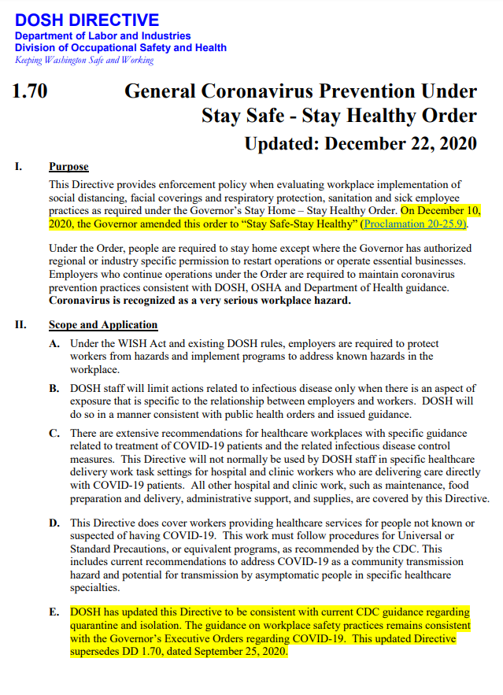

Appendix B, 1-13: DOSH Directive 1.70, dated 12/22/20 Page 2 of 14
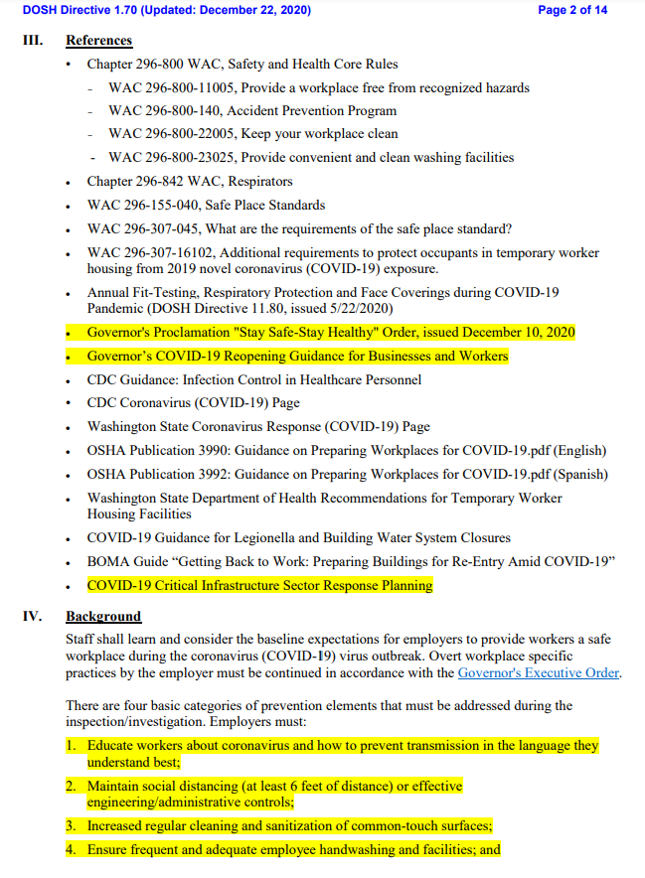
Appendix B, 1-13: DOSH Directive 1.70, dated 12/22/20 Page 3 of 14
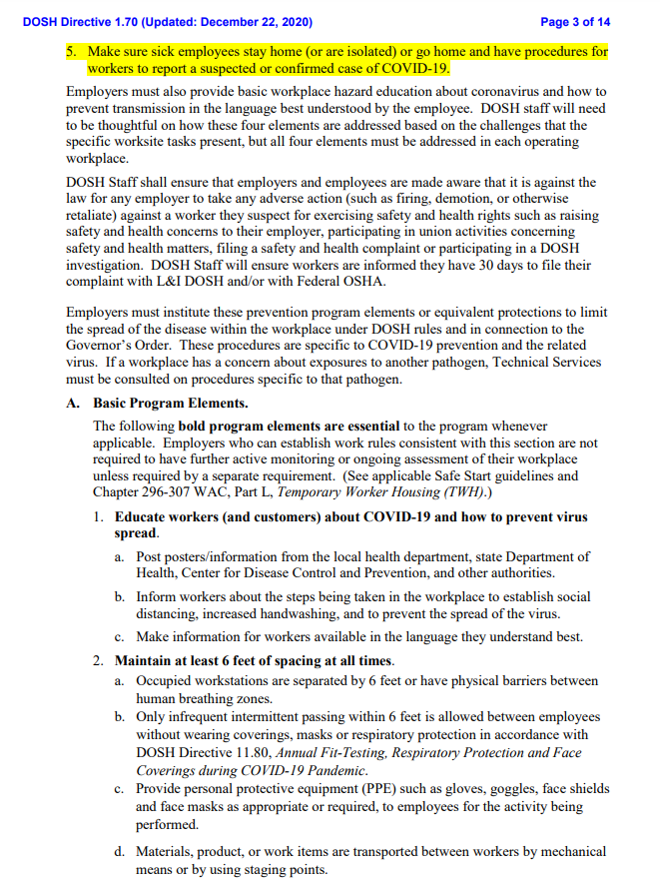
Appendix B, 1-13: DOSH Directive 1.70, dated 12/22/20 Page 4 of 14
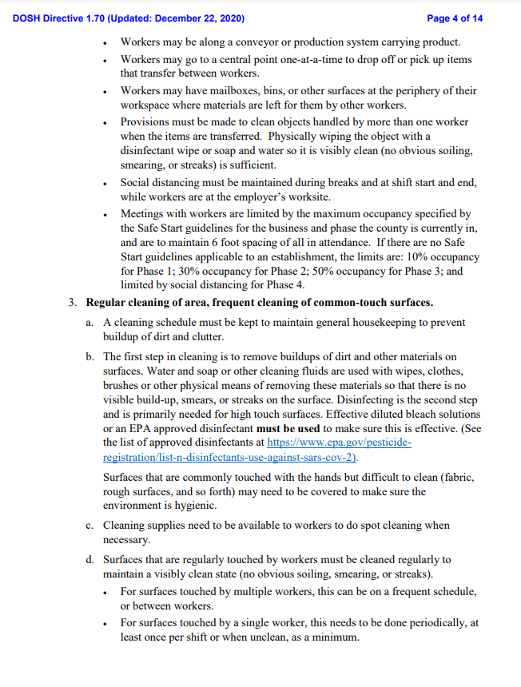
Appendix B, 1-13: DOSH Directive 1.70, dated 12/22/20 Page 5 of 14
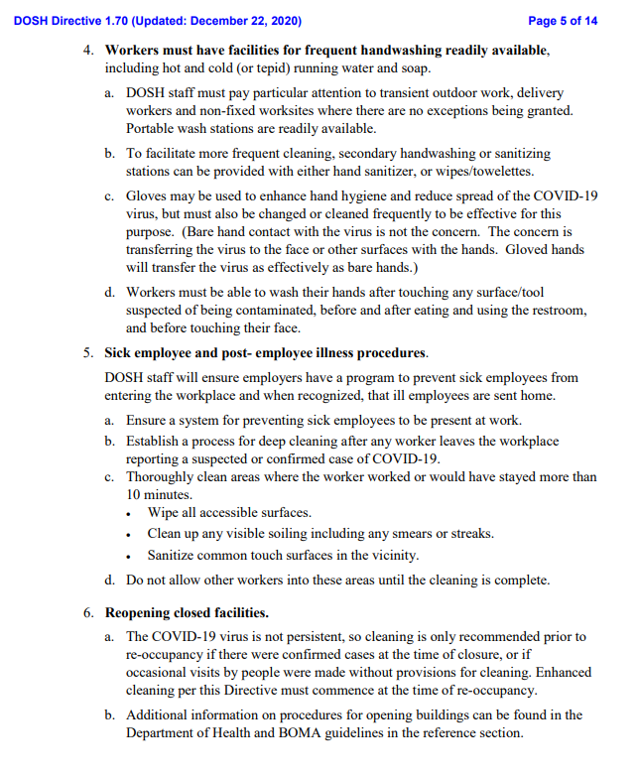

Appendix B, 1-13: DOSH Directive 1.70, dated 12/22/20 Page 6 of 14
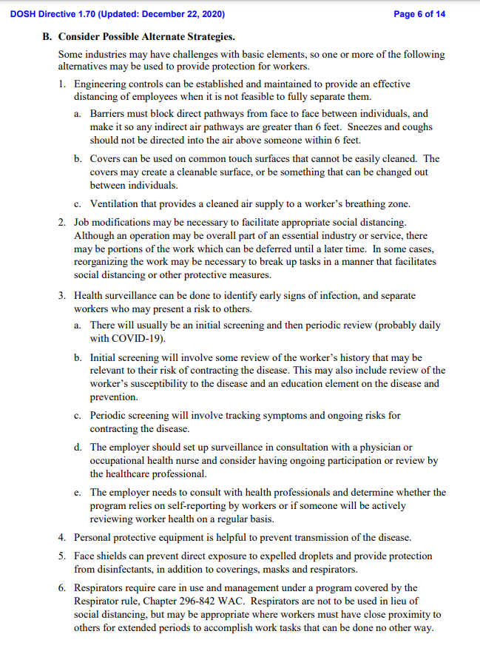
Appendix B, 1-13: DOSH Directive 1.70, dated 12/22/20 Page 7 of 14
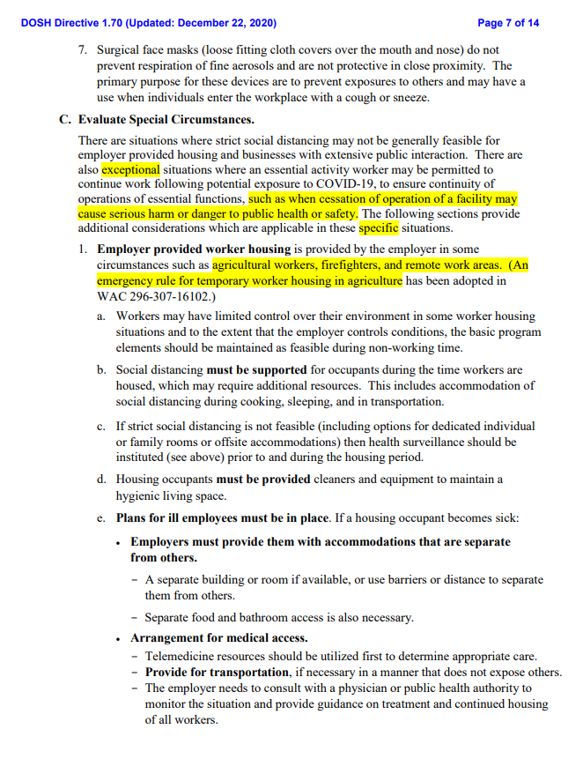

Appendix B, 1-13: DOSH Directive 1.70, dated 12/22/20 Page 8 of 14
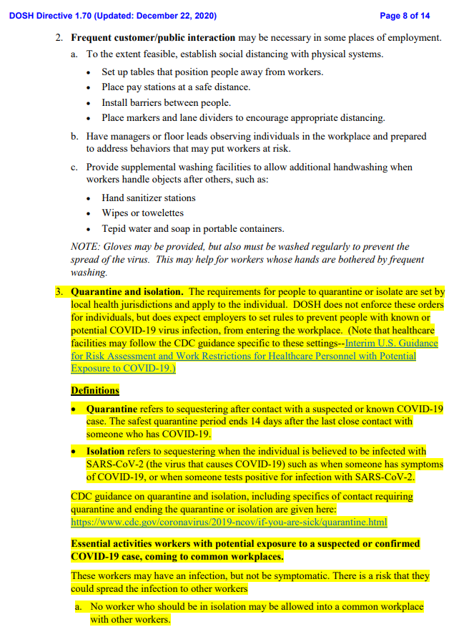
Appendix B, 1-13: DOSH Directive 1.70, dated 12/22/20 Page 9 of 14
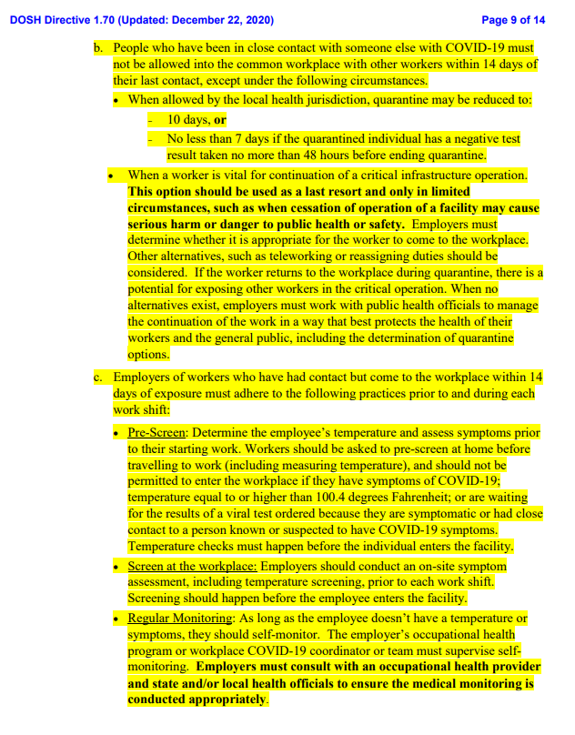
Appendix B, 1-13: DOSH Directive 1.70, dated 12/22/20 Page 10 of 14
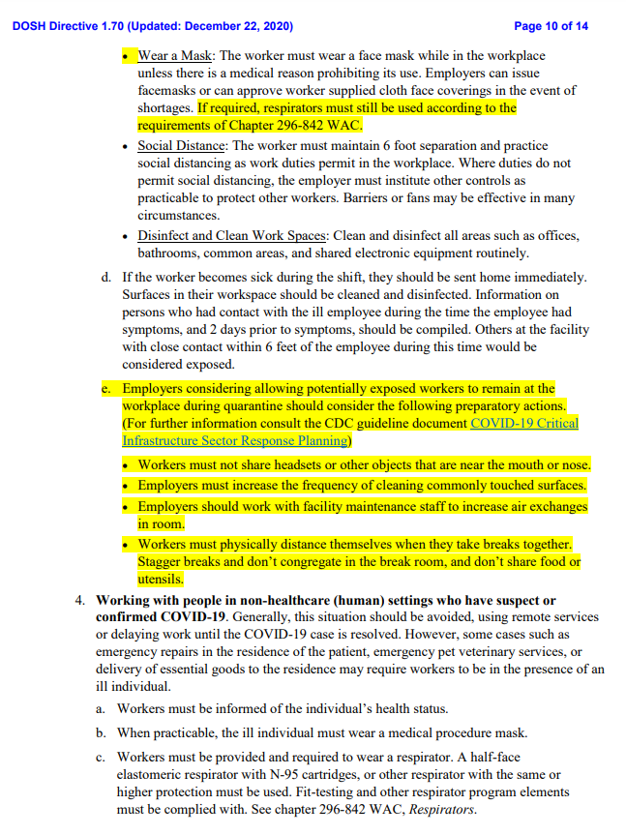
Appendix B, 1-13: DOSH Directive 1.70, dated 12/22/20 Page 11 of 14
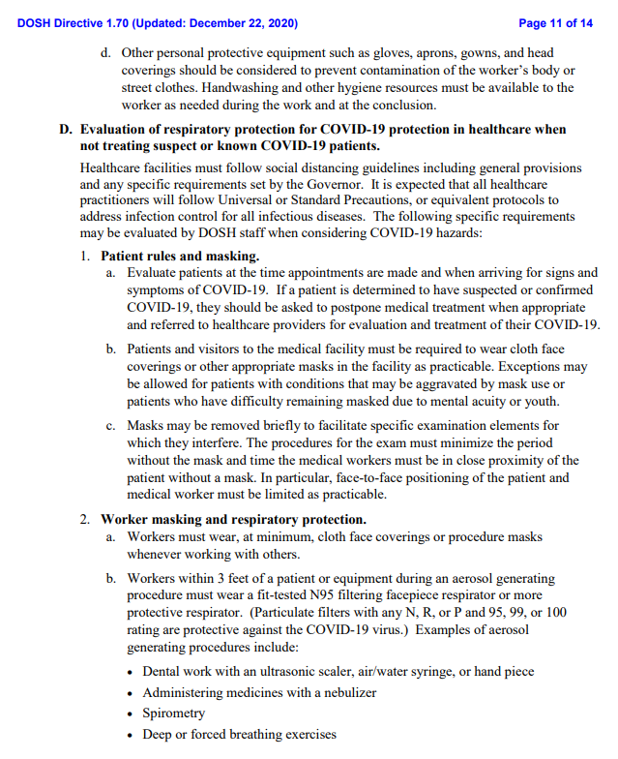

Appendix B, 1-13: DOSH Directive 1.70, dated 12/22/20 Page 12 of 14
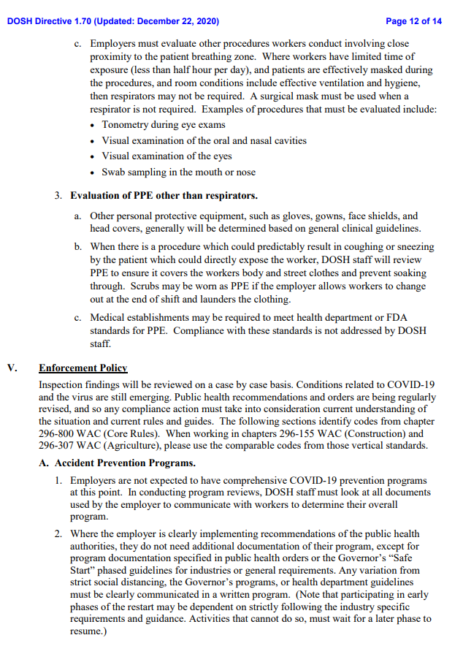
Appendix B, 1-13: DOSH Directive 1.70, dated 12/22/20 Page 13 of 14
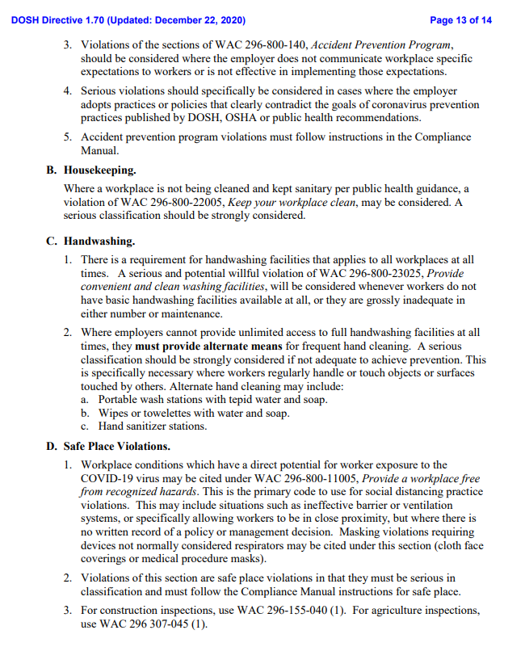

Appendix B, 1-13: DOSH Directive 1.70, dated 12/22/20 Page 14 of 14
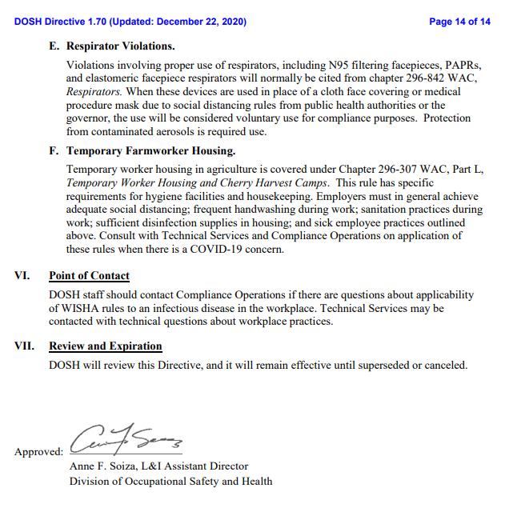

Appendix C 1-2: Washington Department of Health Workplace Page 1 of 2
and Employer Resources and Recommendations
Appendix C 1-2: Washington Department of Health Workplace Page 2 of 2
and Employer Resources and Recommendations
Appendix D 1-3: Incident Investigation Report Form Page 1 of 3
Appendix D 1-3: Incident Investigation Report Form Page 2 of 3
Appendix D 1-3: Incident Investigation Report Form Page 3 of 3
Appendix E1 Job Hazard Analysis (JHA) Page 1 of 1

